Who’s More/Less Alike?

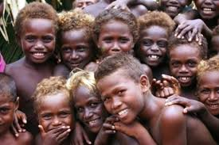

Genotype and Phenotype: What You Get Isn’t Always What You See

Quick Check: What is the difference between genotype and phenotype?

Did you use genotype or phenotype to draw a conclusion and make an assertion about alikeness, or differentness?

What do people generally use to determine skin color?

What actually determines skin color?

Notes:

Let’s take another look at your report for traits:

You should be able to find them under the categories of Skin Pigmentation Freckles

Note: sometimes freckles are hard to see on dark-skinned individuals, but give it a try!

What Elizabeth saw: | What you saw:
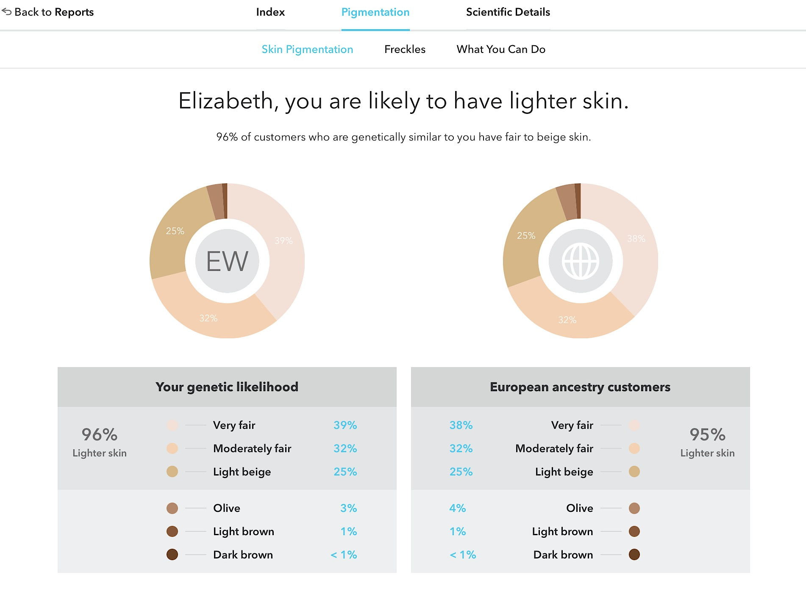 | Surprised by anything?  Does your genotype match your phenotype?
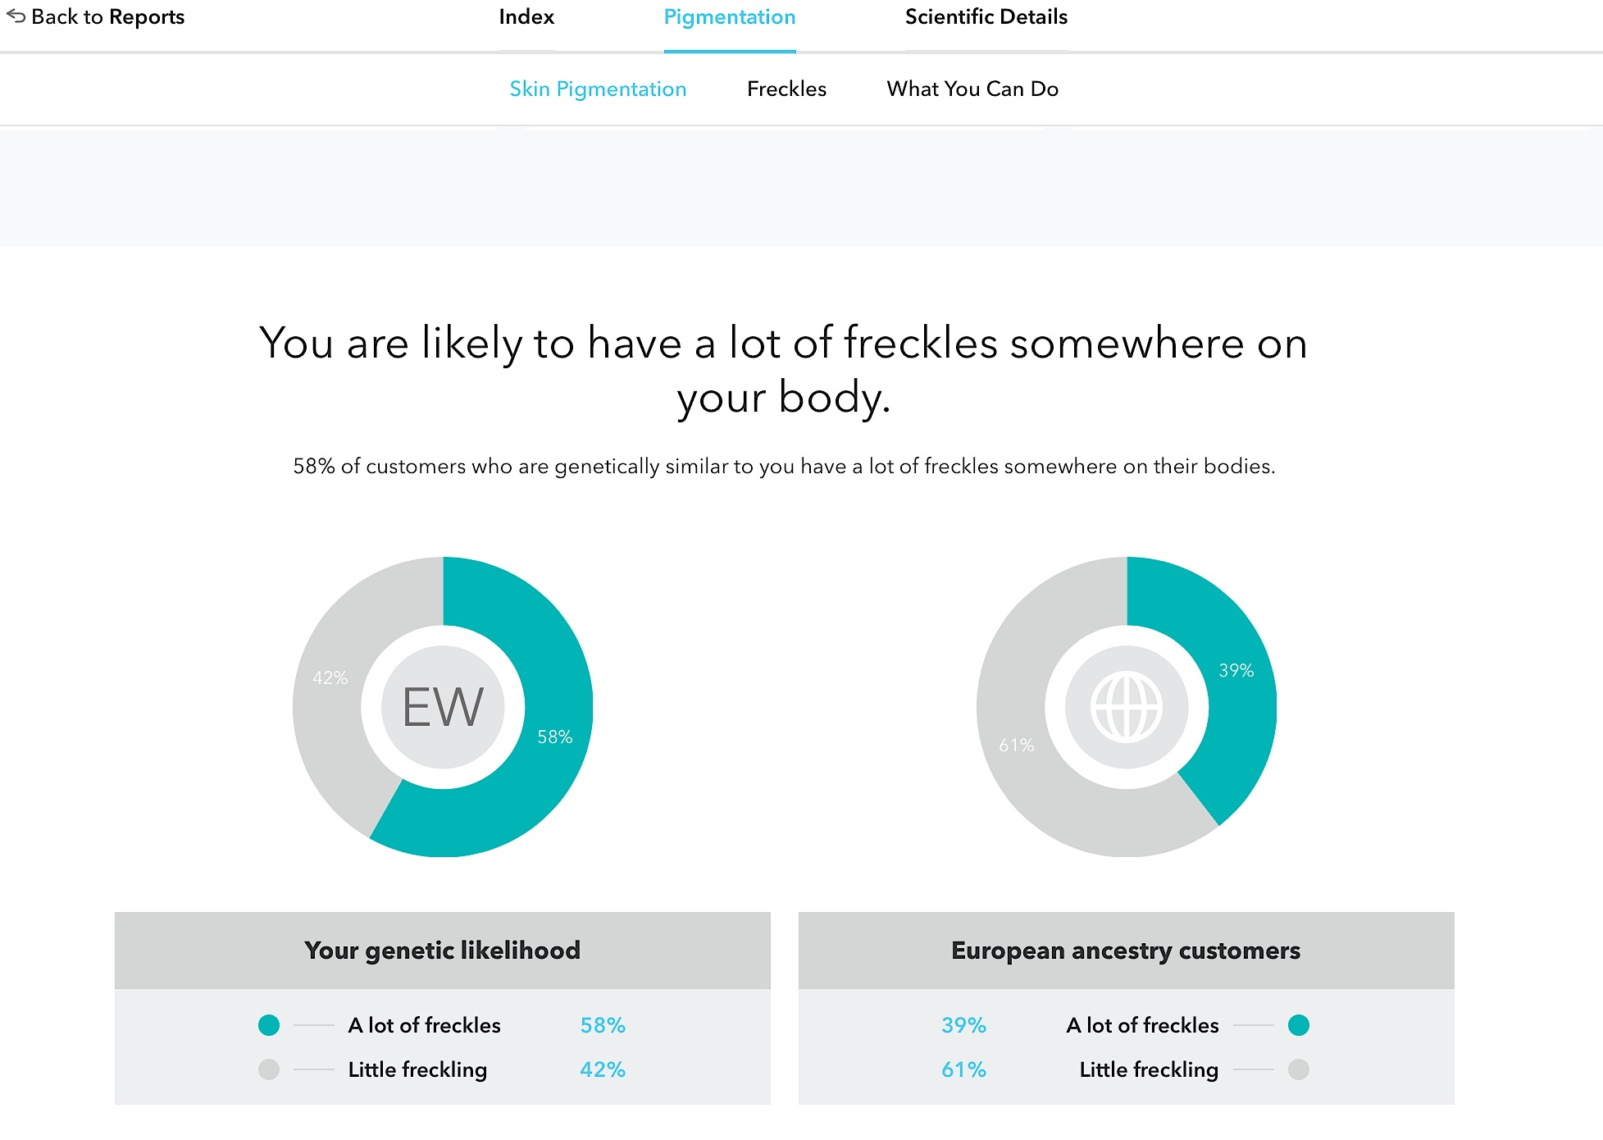 | Surprised by anything?  Does your genotype match your phenotype?

What do you see when you look at all of the data together?

How do you describe your skin color?

How does one of your friends/classmates describe your skin color?
What did your report predict about your
skin color?

Skin color and geographic placement (someone pass the sunscreen, vitamin D, and folate)

Quick Check: What do you know about skin color and where people live on the Earth?

How has skin color evolved over time?

What does “evolve” mean?

Take a guess: do you think geography (where you live) plays a role in the evolution of skin color?

This image represents the distribution of skin color across the globe.

What do you notice?

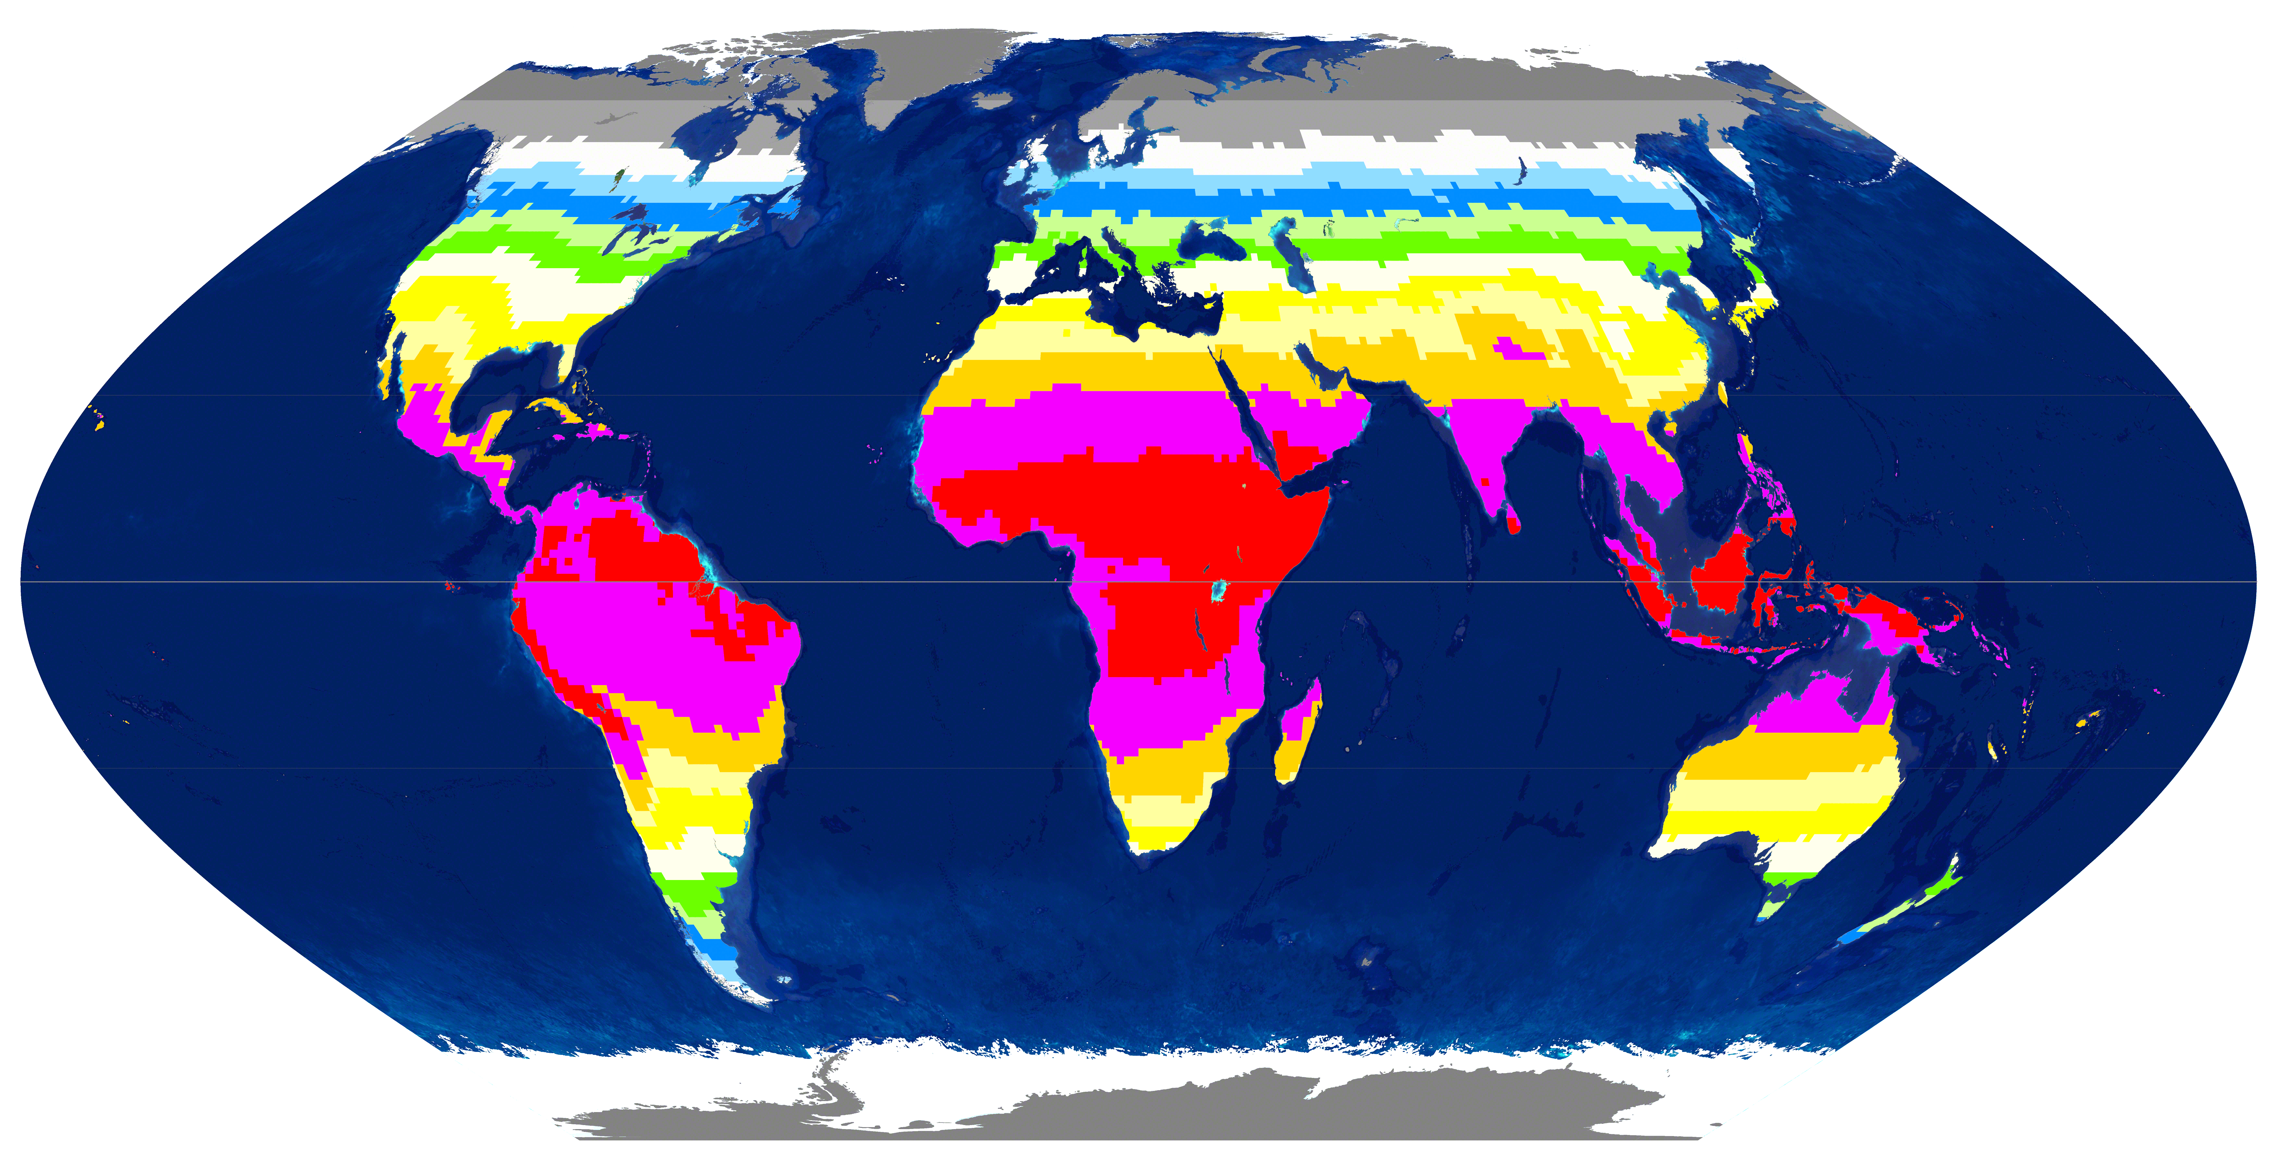 | This image represents the distribution of UV-B radiation across the globe.  What do you notice?

Think About It: What’s the connection between these two images?

