Doing Genealogical Research on Your Family

Using the skills that you acquired this morning, you’re going to do some genealogical research on your family.

Before you start to think about who your ancestors were and where they were from, I want you to think about how many of them there are.

No human on this earth is here without a biological egg and sperm donor. It’s not possible. You are no exception; you have a biological mother and father.

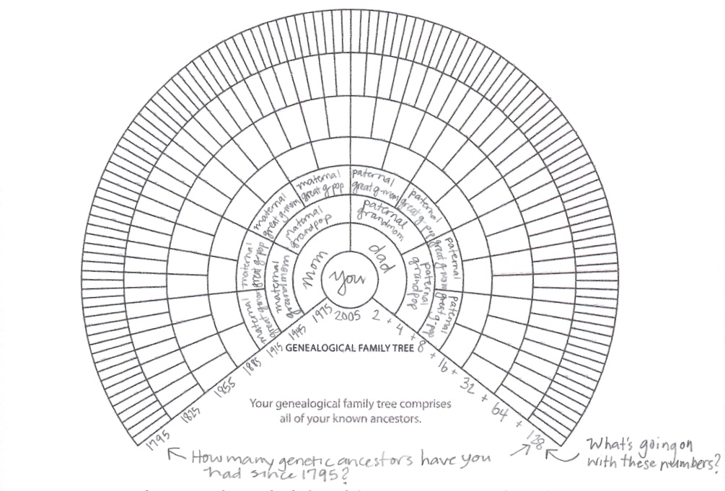

Note: I used 2005 to represent the average age of our campers, and 30 years per generation because for every family that had a child at 20, there is another family who had a child at 40.

How many ancestors have you “accrued” (that means gathered, or added up) since 1795?
Do the math here:

How many do you have if you go back another 210 years?

How many years back do you have to go to find 100,000 genetic ancestors?
No, I’m not kidding

Now let’s get back to your whole family…

Start with the research that you started at home:

- 5-Generation Family Tree
- Questionnaire
- Interview Questions

Using what you learned from these documents:
- Pick a grandparent or great-grandparent to begin with. Using a great/grandparent will increase that chances that you can find U.S. Census data (which doesn’t get released to the public until 72 years after the census was completed!).
- Save screenshots! (control-command-3)
- Import stuff to your eBook that you’re creating

If you want to scan photos, documents, or other artifacts, ask your teacher or another adult for help if you need it!

Head’s up: If you get frustrated, take a break. Check in with someone who’s having success. Ask them what they’re doing and see if that helps. If you’re still frustrated, focus on organizing what you already know about your family. Use it to create a family tree with as much detail as possible.

